**User Manual**

NLP Recommendation System

**Professor Carlo Lipizzi**

**Kunal Batra**

**Hojat Behrooz**

**Arya Guddemane Vishwakumar**

Table of Contents

Login Page 3

The Result Section 5

Show My Files 6

Admin’s Login Page 7

Create a New User 8

List of Users 9

Change Account Password 12

Remove User 12

# **Login Page**

The login page is used to login to the website with user credentials that was created by the **admin** in a different page.

The figure below shows the login page

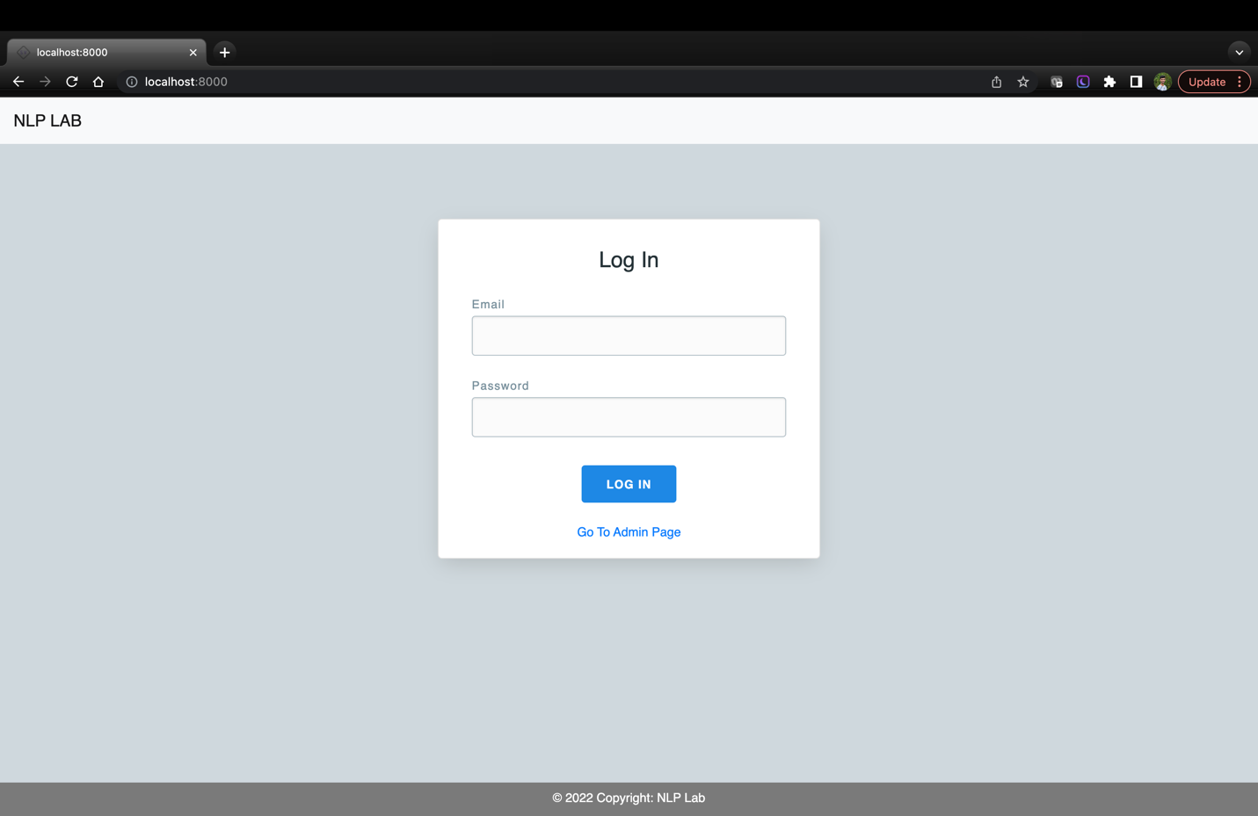

Link for the admin login page

User is directed to the home page if the user exists

Password of the user

Email of the user

The user can enter the email and password that was used by the admin while creating. If the user doesn’t exist or if the password/username is incorrect, “Invalid login credentials” message will be displayed.

“Go To Admin Page”: This link directs to admin’s login page.

Once the user logs in, a homepage will be displayed. This homepage contains the following components:

1. Dropzone to Drag n drop the file, or browse the file
2. Upload the documents (with an option to save files and results to the database)
3. Submit the documents for processing
4. Change the password, Clear the session and Sign out
5. Results section
6. A link to show files that were previously uploaded

**Homepage**

The below figure shows the **homepage** of the user.

To view all uploaded

files

Result Section

Dropzone to drag and drop

the files

The user can upload multiple files or an individual file. Once the user uploads the documents, the submit button must be clicked to process them. Then the processing of the files takes place in the background, which takes around 1-2 mins depending on the size and number of documents uploaded.

The processed document in then displayed in the “Results” section at the bottom of the page. Initially displays “Nothing to display” as there were no documents present when the user logged in.

The files and results are present in the homepage only when the user is logged in. These files are cleared once the session is cleared i.e., when the user clicks on **“Clear Session”** or **“Sign Out”** link on the top of the page. To avoid the risk of losing files and results, it is important to check “Save Files” and “Save Results” options while uploading the document.

**“Save Files”** and **“Save Results”:** This option lets the user to decide if the uploaded file and processed results should be saved in the database for future reference. These two options are checked by default, if not the user will have option to do so after processing the document.

**What happens if the user unchecks the “Save Files” and “Save Results”?**

If this happens, the user can upload the file to the database from the **result section**. If the file is uploaded but not processed, then the user can process those files from the **result section.** The results can also be saved into the database.

# **The Result Section**

Once the files are processed, the results are visible at the bottom of the page. They are arranged in a table format with links to **view results** of individual or multiple files, a link to **download** all files and results in a zip format.

When the **View Results** link is clicked, similarity charts are shown as below:

The **Close** button hides the results and the **Class** button is a dropdown selection used to select a class.

Scroll down to view the highlighted files

# **Show My Files**

**Show My Files:** This link lets the user to view all the files that were previously uploaded to the database.

The below figure shows **“Show My Files”** page

The links such as **View Results, Delete file, Download Zip,** and **Archive** is used to display the results, delete particular file, download files and results and archive respectively. The results are displayed like as it was in the homepage.

When a file is archived, it will be invisible to the user and can be unarchived only by the admin.

Clicking on the file name opens the original file.

# **Admin’s Login Page**

The admin can login to the system using admin login credentials, (username: admin, password: admin). The admin has the following privileges on the user:

1. Create New User
2. Delete an existing user
3. View files and results of users
4. Change password of user
5. Archive or unarchive user files

The below figure shows the login page for admin

Directs to create new user page

Password of the admin

Username of the admin

Once the admin logs in, he/she will be prompted to create a new user. A link to **show all users** is also provided on this page.

When a new user is created, “User sign up successful” message is displayed. Password requirements should be met while creating a new one. Those are:

* Minimum of 8 characters
* Atleast one capital letter
* Atleast one small letter
* Atleast one special character
* Atleast one digit

# **Create a New User**

The below figures shows the page to **create a new user**

Admin Sign-out

Link to show all users

Successfully creates a new user and displays a success message

Password of the new user

username of the new user

email of the new user

# **List of Users**

The below figure shows the **list of users**

Link to remove user

Link to change the password

Link to view files

and results

The below figure shows the **files uploaded by user;** this is displayed when **“Show Files”** link is clicked from the above image.

This page lets the admin to view the results, delete a file, download results in zip format, and archive/unarchive files

**Viewing the result** shows the highlighted pdf file, similarity chart and class-wise similarity chart.

**Deleting a file** removes it permanently from the database and cannot be recovered.

**Download Zip** includes highlighted version of the original file, similarity chart and class similarity chart.

If the file is **archived,** only the admin can see those files but not the user (as shown in below image). The admin can unarchive those files for the user. When the file is unarchived, it is made visible to the user as well.

The below figure shows the **archived file**

The **“View Results”** shows up as follows



Class similarity

Similarity Chart

Scroll down to view the **highlighted file**

# **Change Account Password**

The below figure shows the “Change Account Password” page. This is displayed when the “Change Password” link is clicked on “Show User” page.

# **Remove User**

The **Remove User** link can be used to delete a user from the system. A warning message is displayed before deleting a user.